This document is a blog that illustrates the last few months of labor demands across the country, in CA, and for a selected handful of different jobs. The 10 most populated cities in each state were selected and on a weekly basis job advertisement header information was pulled from Indeed.com from these 10 cities from July 20, 2020 to August 17, 2020. Jobs are posted as 'just posted' or 'today' under the Indeed.com tag of 'days posted' and up to 30 days, but anything over than 30 days posted gets categorized as 30 days, so those dates were removed. This counts those postings that are fresh on each day starting 29 days before July 20th as June 21, 2020 and on August 17, 2020 when the data was pulled. R was used to calculate, web scrape, and document the steps. The R markdown file is in my github repo on state licensing for LMTs at github.com/janjanjan2018.

These images are images of the interactive charts available and encouraged for you to explore at my Tableau Public Server repository at tableau.com/janisharris. Just click an image and it will direct you to the chart in a separate window you can keep open to read through the image information and notes and look through the charts to discover something new or confirm what you see or make interesting findings on the labor demands of the country and our state.

The selected jobs that are compared to LMT job demand are nannys, nurses, personal assistants, security, and warehouse workers. The nurses missed a week on August 3rd because it was renamed when moving files and never got pulled, but the other data somewhat makes up for it, because each job says how many days ago it was posted so that should resolve that problem.

You will see maps of the country, the state, the 10 most populated cities according to worldpopulation.org, bar charts, stacked bar charts, line charts, area line charts, and more. Note on the area line chart, that it doesn't matter which category is on top, only how much area of their color dimension is shown. And that area is given as the number of jobs for a date on the area line chart time series of job postings for each category of job.

<https://public.tableau.com/profile/janis5126#!/vizhome/LMTpostingsJul20Aug17cities/LMTpostingsJul20Aug17citiesBarchart?publish=yes>

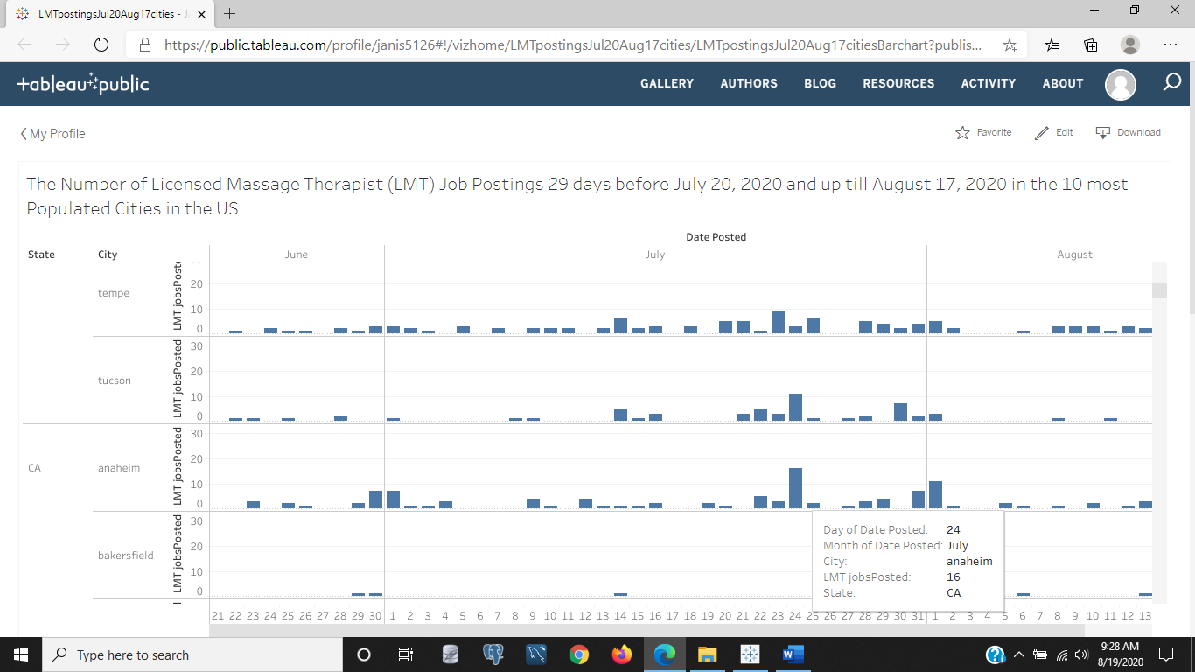

Figure 1: The number of LMT job postings 29 days before July 20, 2020 and up till August 17, 2020 in the 10 most populated cities in the US. This is a bar chart showing the 10 cities spanning the date July 27th as the start and August 17th as the end on a weekly pull from Indeed.com that goes back 29 days and not 30 to avoid those actually many days past 30 days posted but grouped into 30 days 'posted ago' in the timeline of each advertisement for a job. There are some days that no jobs were posted in a city and for many days in some parts of the US. Others had days that had many jobs posted on the same day.

<https://public.tableau.com/profile/janis5126#!/vizhome/LMTpostingsJun24Aug14citiesMap/LMTjobsPostedJunAugMap?publish=yes>

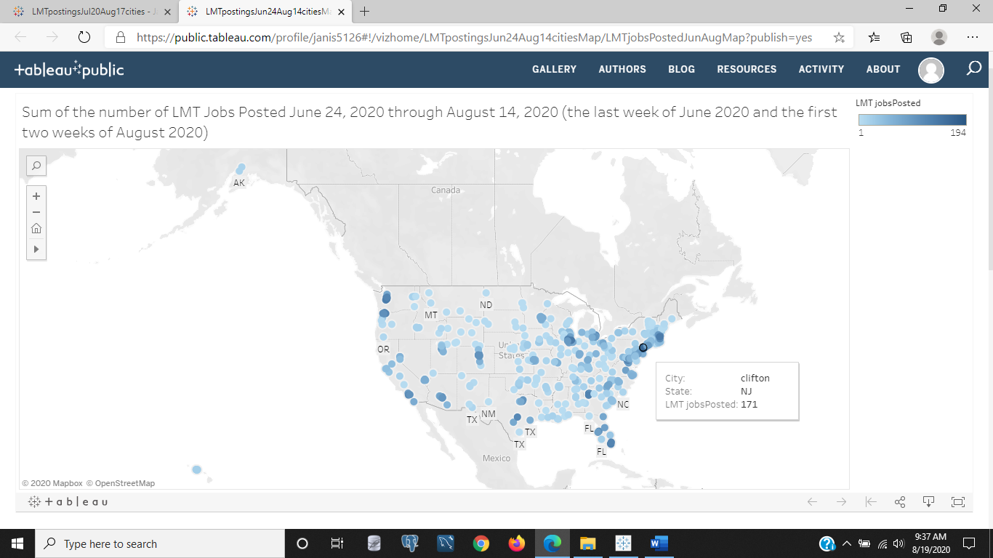

Figure 2: This is a sum of the number of LMT jobs posted June24, 2020 through August 14, 2020 as the last week of June and the first two weeks of August. We can see some of the 10 most populated cities in each state have had darker scatter spots indicating a lot of job postings in relation to the rest of the US, such as New Jersey and New York, Florida, Washington, Arizona, Texas, and southern CA.

<https://public.tableau.com/profile/janis5126#!/vizhome/LMTpostingsJun21Jul12-2ndQuarknowldgCA-Map/LMTjobsPostedbefore2ndQuarMap?publish=yes>

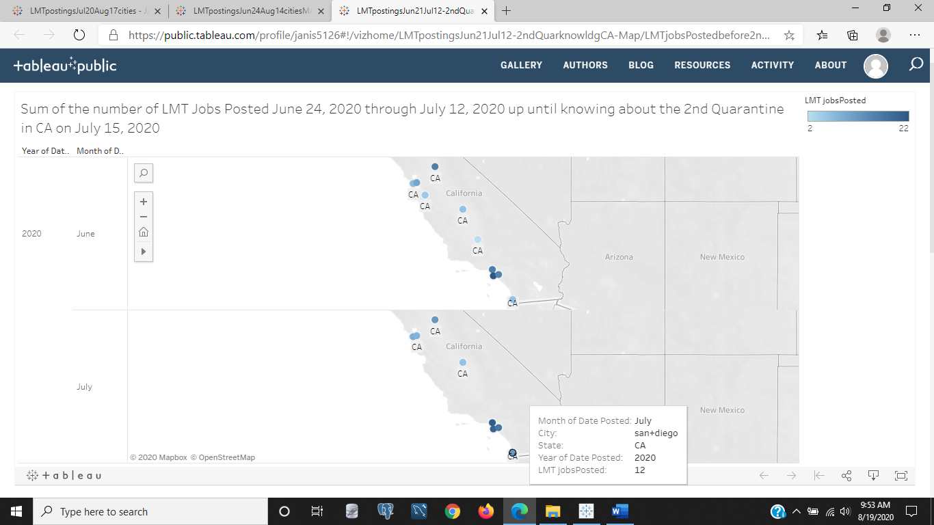

Figure 3: This image is a map of CA's 10 most populated cities' sum of LMT job postings from June 24-July 12, 2020 before businesses in CA knew about the 2nd quarantine that would shut their gyms, massage spas or clinics, and nail or hair shops if they weren't made to deliver those services out doors. Restaraunts and theaters were already closed for a week before this date in early July. We can see that the darker spots indicate there are many jobs posted advertising a need for LMTs in northern and sourthern CA in June and July.

<https://public.tableau.com/profile/janis5126#!/vizhome/LMTpostingsJul13-Aug17-2ndQuarknowldgCA-Map/LMTjobsPostedafter2ndQuarMap?publish=yes>

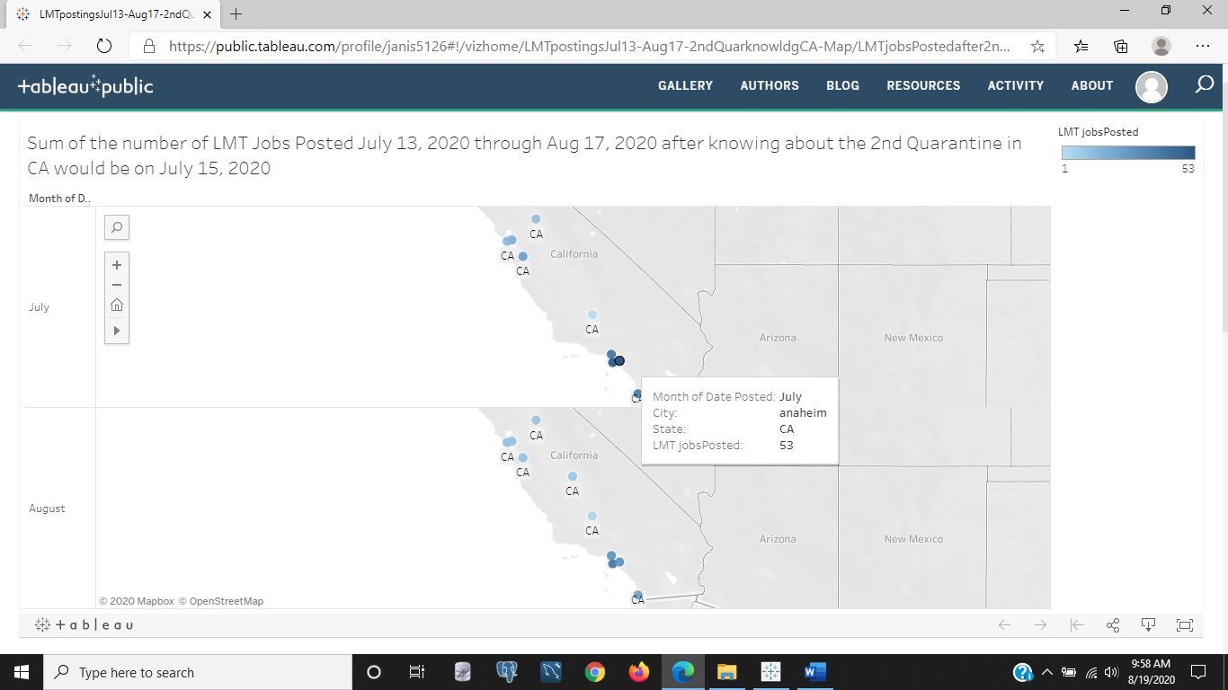

Figure 4: This image above is a map of CA that was shown in Figure 3, except the date is different. This time the date spans July 13-August 17,2020, after CA businesses knew about the 2nd quarantine that would shut down their business or cut business services drastically if they can only accomodate a few customers outside. We see that there are a lot more southern CA businesses advertising for LMTs in July than in August.

<https://public.tableau.com/profile/janis5126#!/vizhome/LMTpostingsJun21Aug17citiesCABarchart/LMTpostingsJun21Aug17citiesCABarchart?publish=yes>

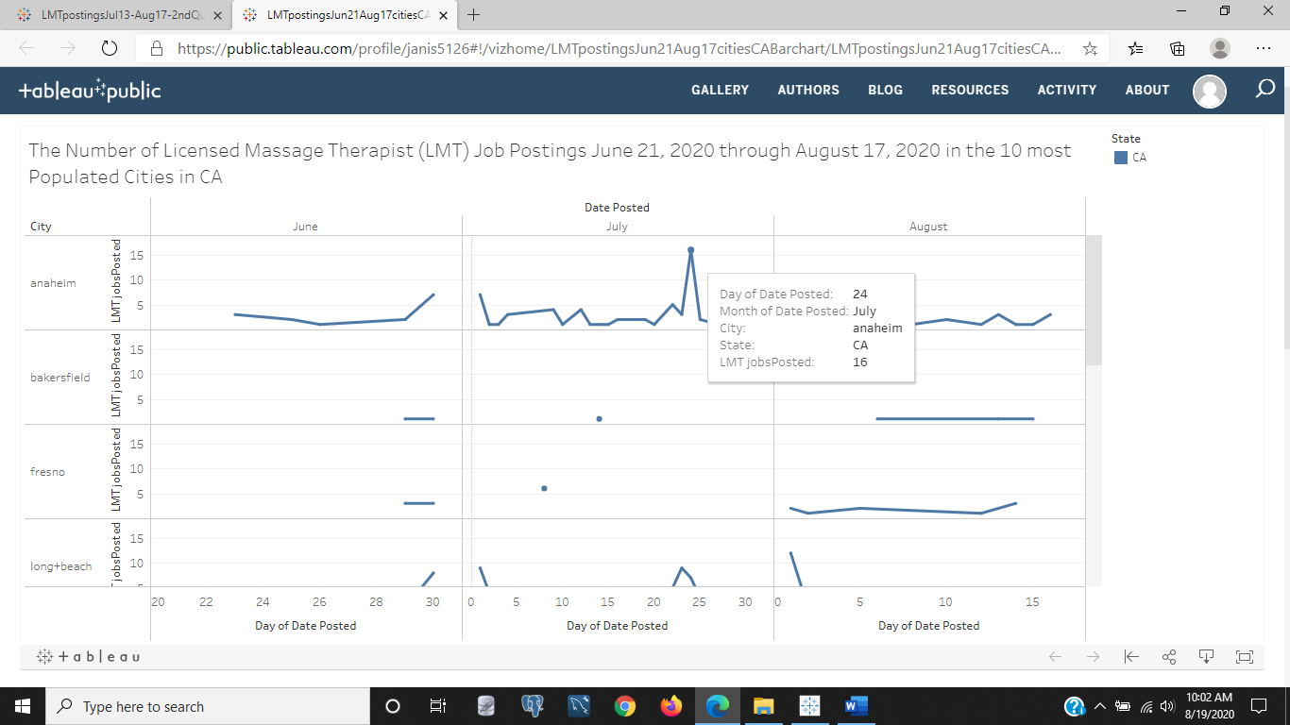

Figure 5: The above image is a line chart by month and by city in one of the 10 most populated cities in CA from June 21-August 17, 2020 showing the rise and fall of advertised job postings for LMTs in Calirfornia. Some days have none and some seem to make up for missed job postings. The chart shows in Anaheim on July 24, 2020, there were 16 jobs freshly posted on Indeed.com for LMTs.

<https://public.tableau.com/profile/janis5126#!/vizhome/JobsJunAug2020stackedBarchart/JobsJunAug2020stackedBarchart?publish=yes>

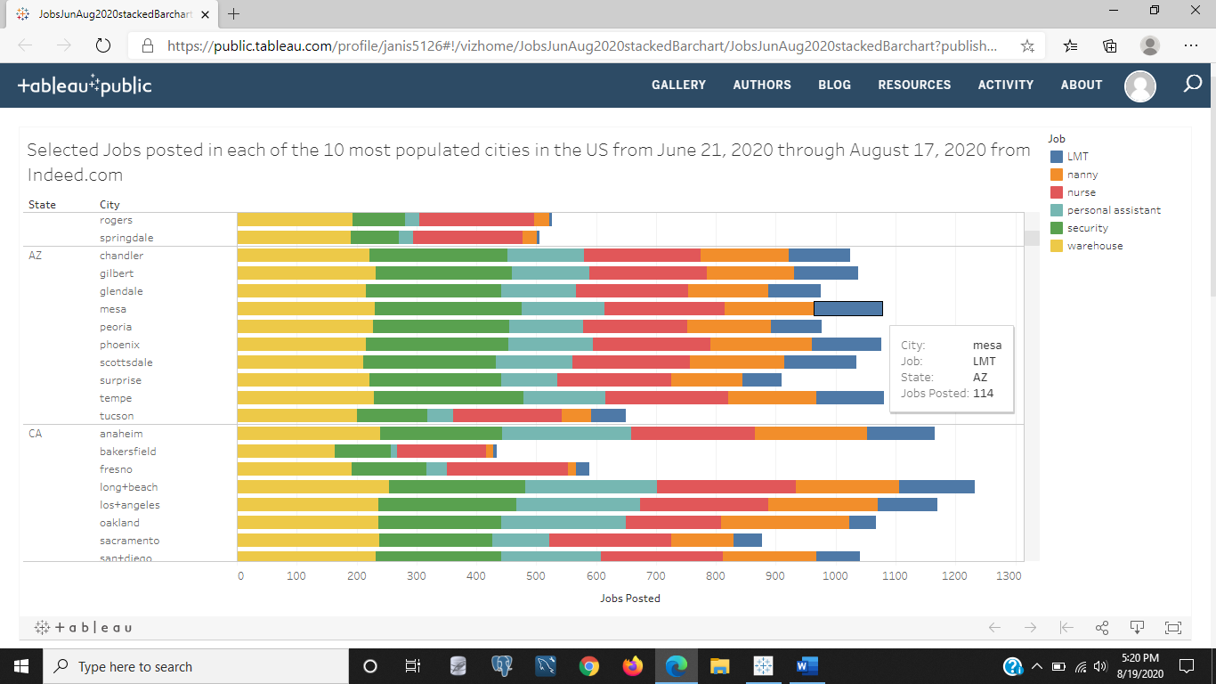

Figure 6: The above image is a stacked bar chart that indicates by color those alternate and/or essential jobs as a comparison to LMT job demand from June 21, 2020 through August 17, 2020. I didn't just pull web data every monday on LMTs but also on 22 different jobs. I selected these jobs for this document to illustrate the effects of the quarantine and needs by businesses for labor. Each of the 10 most populated cities in each state is shown as a stacked bar, where you can see that yellow is for warehouse, green is for security, light blue is for personal assistants, red is for nurses, orange is for nannys, and blue is for LMTs. When hovering the sum of total job postings between June 21st and August 17th will be displayed. We can see from the image above that Arizona and CA seem to have had similar labor demands of these professions or jobs as each other, but a few cities like Tucson, AZ and Bakersfield and Fresno, CA have little to no demand for personal assistants.

<https://public.tableau.com/profile/janis5126#!/vizhome/JobsJunAug2020linechartStates/JobsJunAug2020linechartStates?publish=yes>

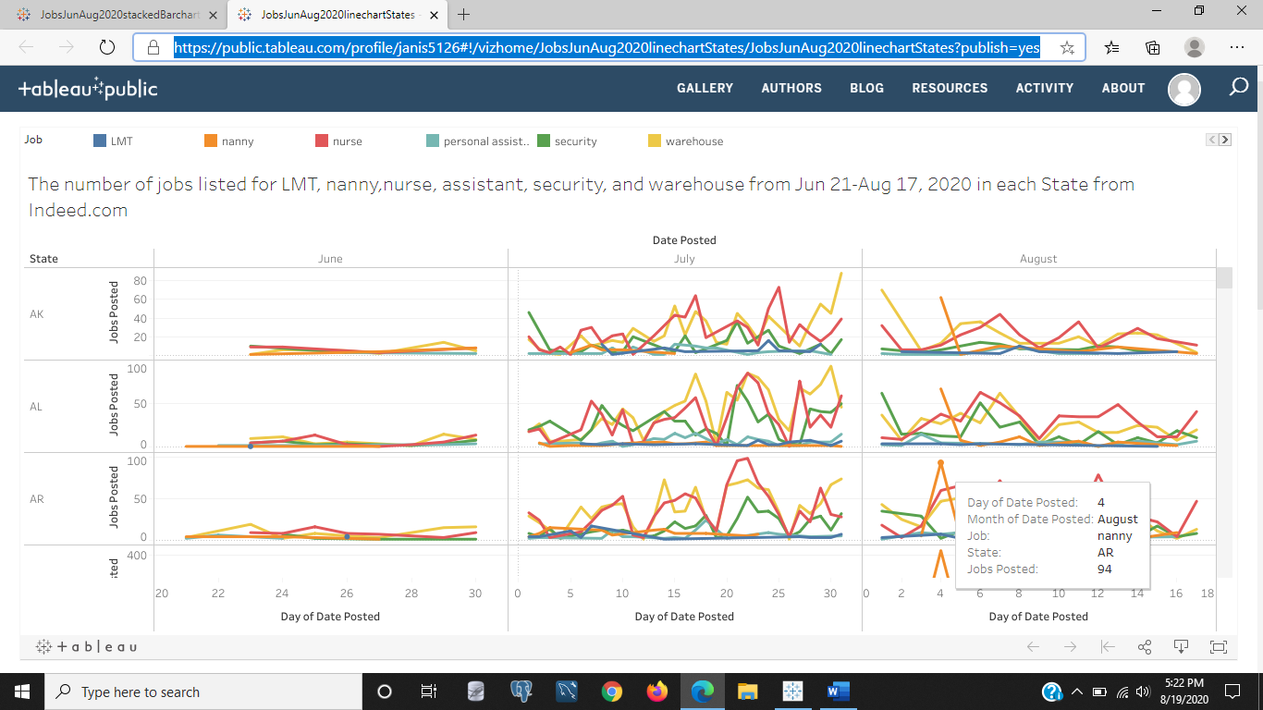

Figure 7: The image above is a line chart from the span of this analysis from June 21-Aug 17, 2020 of the number of jobs posted each day for either an LMT, nanny, nurse, personal assistant, security, or warehouse worker. We can see there was a spike in nanny demands for employment on August 4th, with 94 jobs requesting a nanny posted that day in Arkansas' 10 most populated cities. We know this by hovering over the spike and seeing the information box pop-up.

<https://public.tableau.com/profile/janis5126#!/vizhome/CA_jun-julyMapJobsPosted/CA_jun-julyMapJobsPosted?publish=yes>

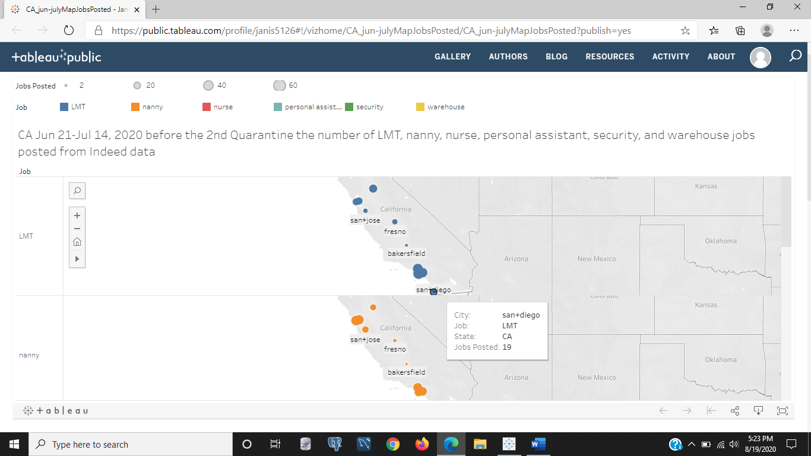

Figure 8: The image above shows the demands by job in CA from June 21-July 14, 2020, before the 2nd quarantine started. If you scroll through the chart this image links to, you will see the scatter of all job categories shown for LMTs, nannys, nurses, personal assistants, security, and warehouse workers. The size is a dimension indicating the most job demands for that category as well as color for the category color, such as orange for nanny and blue for LMT. The scatter on the map is showing that San Diego, CA had 29 jobs advertised for LMT between June 21st and July 14th.

<https://public.tableau.com/profile/janis5126#!/vizhome/CA_july-augMapJobsPosted/CA_july-augMapJobsPosted?publish=yes>

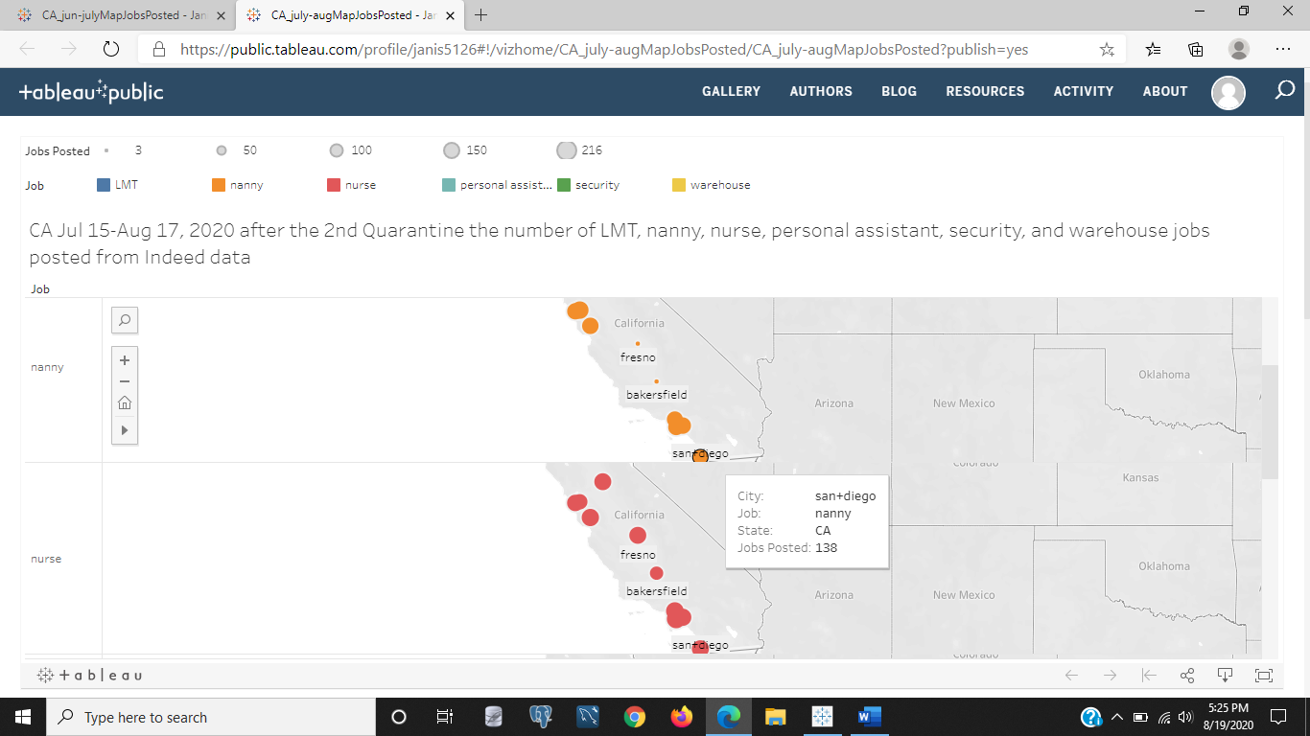

Figure 9: The image above is the same chart as Figure 8, except that the date is July 15-August 17th, the days in our time series after the 2nd CA quarantine. We can see the same color and size dimension for job category and the sum of the number of job postings per category respectively. Above the image shows that in San Diego there were 138 job advertisements for a nanny between July 15th and August 17th. And below that we see a uniform demand for nurses all over CA. The three city blob in the lower portion of CA colored red is the cities of Los Angeles, Long Beach, and Anaheim because those are in the top 10 most populated cities in CA.

<https://public.tableau.com/profile/janis5126#!/vizhome/CA_linechart_10citiesJobsPosted/CA_linechart_10citiesJobsPosted?publish=yes>

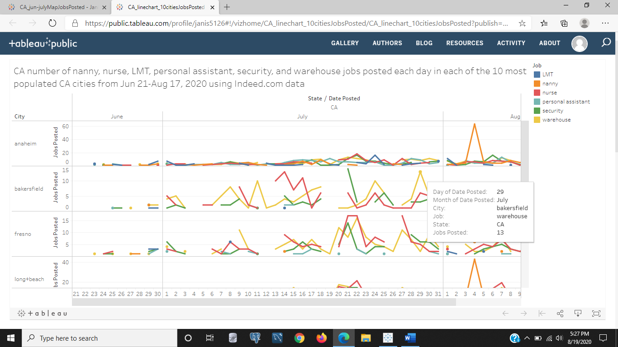

Figure 10: In the above image, it looks very similar to Figure 7 except that this chart only shows the 10 most populated cities in CA for the span of our time series June 21-August 17, 2020. The job categories are color coded, and we see the rise and falls of job demand for each job over time. We see that the point being hovered on represents a spike in warehouse demand in Bakersfield, cA July 29th with 13 jobs posted. Anaheim is skewed relatively flat in job demand for all categories until early August with that huge spike in demand for nannys that shifts the scale to five times the average approximately.

<https://public.tableau.com/profile/janis5126#!/vizhome/CA_discreteAreaChart_10citiesJobsPosted/CA_discreteAreaChart_10citiesJobsPosted?publish=yes>

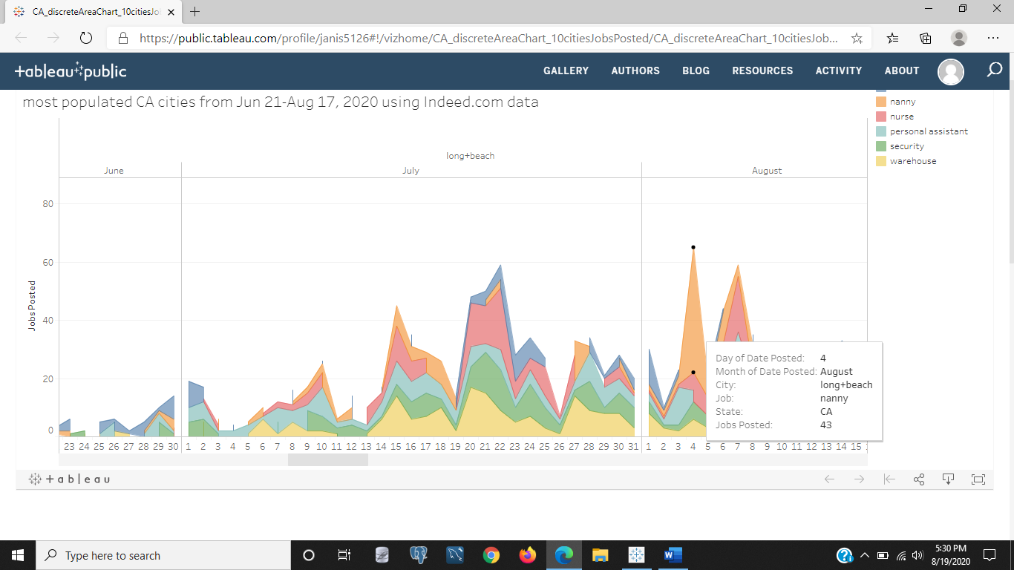

Figure 11: In the above image we see an area line chart color coded by job category. In an area chart, think of it more as a map you lay down flat on the table to see the amount each category or region for the map analogy has showing. For instance, the top area is blue, but the blue doesn't have more job demand than the nurses just that tiny strip showing. The blue is indicative of LMT job demand and red is indicative of nurses, light blue for personal assistants, green for security, and yellow for warehouse labor demands. This map is a city by city comparison of those 10 top populated cities in CA and the demand for these selected jobs from June 21-August 17, 2020. Again we see the day with the most job demands of one category is on August 4th with 43 job advertisements for a nanny in Long Beach, CA.

<https://public.tableau.com/profile/janis5126#!/vizhome/UShourlyWages500CitiesLinechart/UShourlyWages500CitiesLineChart?publish=yes>

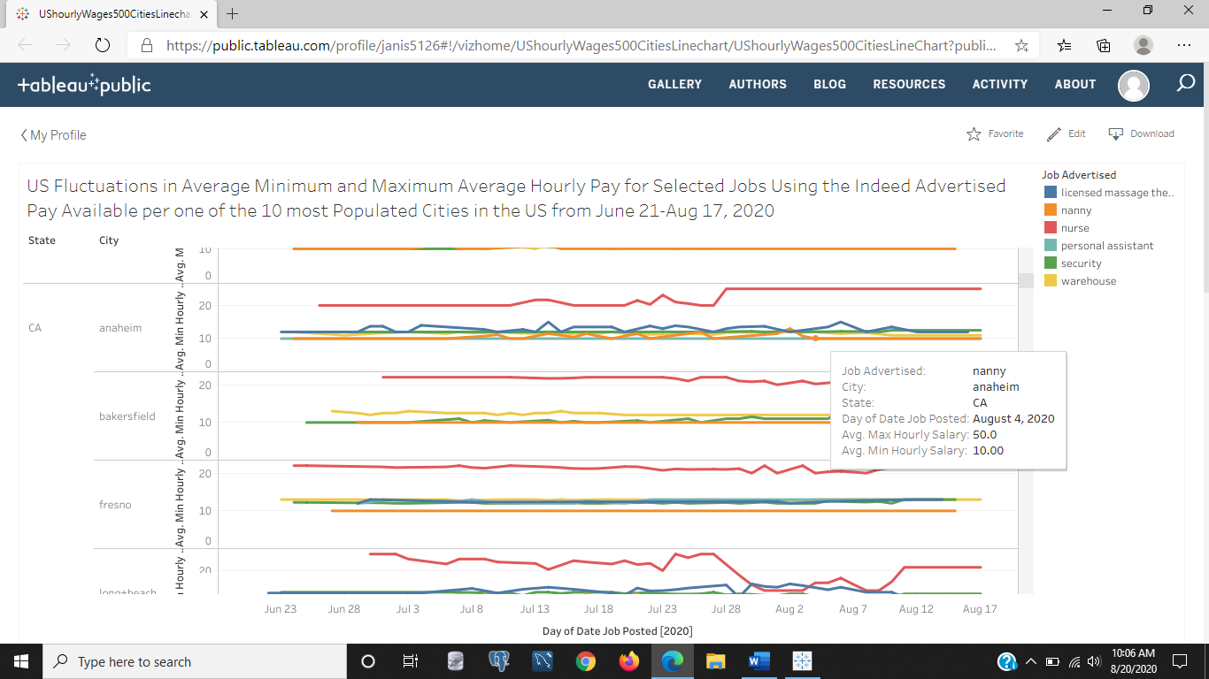

Figure 12: The above image is of the chart that compares the selected jobs' average minimum hourly pay advertised on Indeed.com from Jun 21-Aug 17, 2020. The nanny role is hovered on to show the details, with a minimum hourly pay of $10 and a maximum hourly average pay of $50 that corresponds to the huge spike in demands for Nannys on Indeed on August 4, 2020. All of the 500 cities that include only the top 10 most populated cities in our 50 states if they had data available are shown.

<https://public.tableau.com/profile/janis5126#!/vizhome/CAhourlyWages10CitiesLineChart/CAhourlyWages10CitiesLineChart?publish=yes>

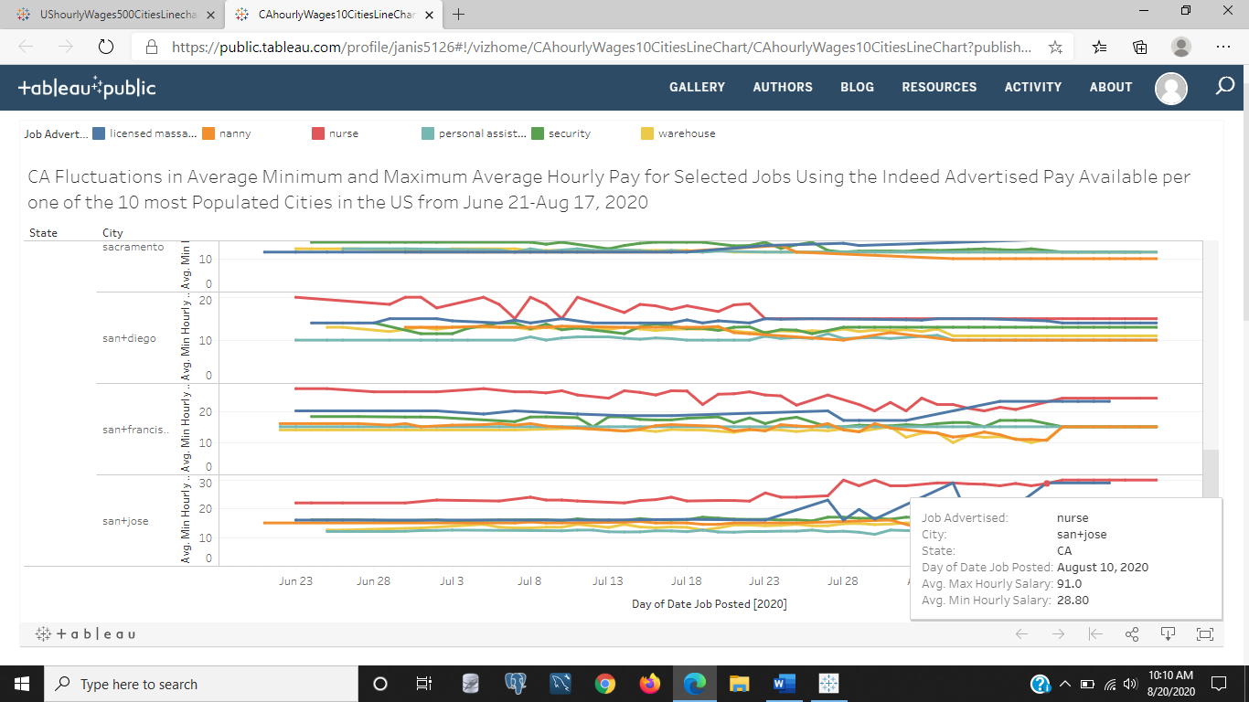

Figure 13: The above image is of a line chart of those 10 most populated cities in CA for their minimum hourly advertised pay for our selected jobs using Indeed data. The selected point on one of the lines shown is for San Jose, with a minimum hourly advertised pay of $28 and a maximum hourly pay of $91 for the nurses that overlaps with the LMT advertised hourly pay on August 10, 2020.

<https://public.tableau.com/profile/janis5126#!/vizhome/CAhourlyWages10CitiesAreaChart/CAhourlyWages10CitiesAreaChart?publish=yes>

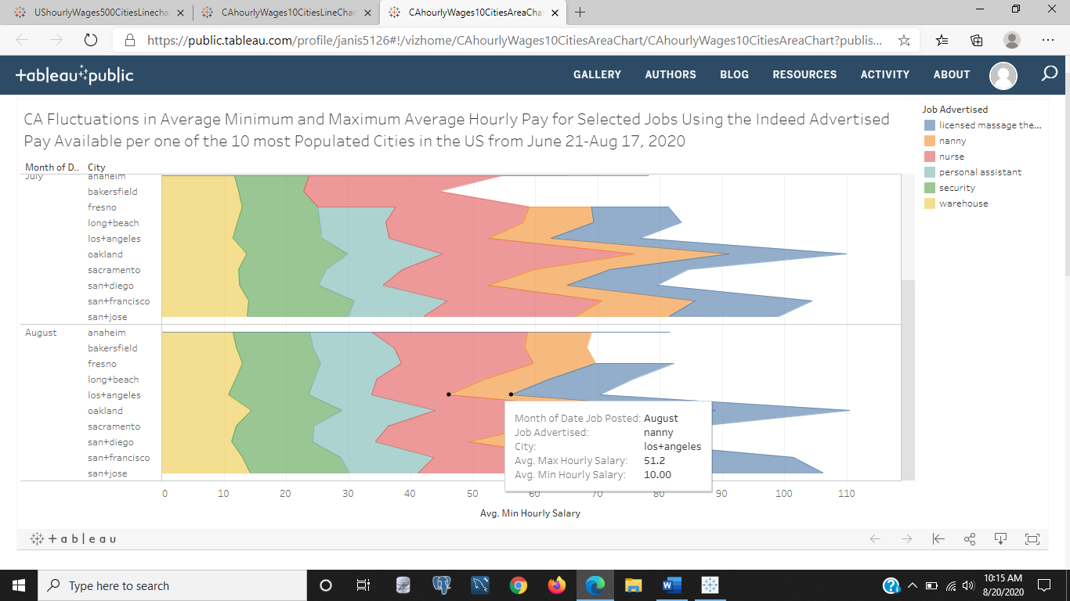

Figure 14: The above image is of an area chart detailing the jobs selected's average hourly pay as an area map for the 10 most populated cities in CA by month as an average of all days in the month for each job in each city. Avoid the numeric scale on the x-axis, as it adds confusion and wasn't able to be removed. Unless you can look and guestimate by the scale subtracting as you would on a map by scale from a start point and end point. For instance, Nanny is either a low or very high paying job ranging from $10-$52 an hour in Los Angeles. Who's family pays $52 an hour is a question I would like to know, if you go up to Fresno the pay range for a nanny is $10-$16 which seems more than likely for households that aren't the wealthy elite like celebrities earning millions a year and then some for royalties. But also notice that the area of the nanny for Los Angeles starts on approximately 45 of the scale of the x-axis and goes to about 65, which is the minimum listed value of $10 if you subtract 55 from 65. Some cities don't have listings, such as Bakersfield and Fresno for nanny or LMT jobs advertised in August or July. But they are two of the ten most populated cities in CA (note to the English majors and so called grammatic punctualists, sorry for the trivial errors in not first word capitalizing the cities, if you can't get past that mistake or trivial ones like it you will never get to the true point of your analytic work--you know who you are Alex, Michelle, old dudes at community colleges picking on older female professors,...).

Thank you for reading this blog and I am certain you found some usefulness out of it and some questions answered that you didn't know you wanted to know. Any ideas for other projects? Please leave a comment and I will respond.

Have a great rest of your day.